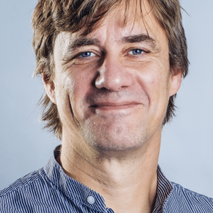

**Örjan Skoglösa**

**Mother tongue: Swedish**

Full member

**Presentation:**

I was born 1961 in Stockholm, raised bilingually in Hamburg (1970-1982) and then moved to Sweden for universitarian literature studies. I have been working professionally as a translator and interpreter since 1989, mostly as a freelancer but also employed twice (1992-1994 and 2008-2015). My field of excellence is law, especially financial and contract law. I hold a Bachelor Degree in Business Law at the University of Lund, specializing in international taxation and german and swedish contract law. Another important subject is technical text, especially from the workshop and automotive sector. As a subcontractor or employed I have during the last 25 years worked with every major german automotive brand. I´m also a graduated and trained truck mechanic. Until recently and during the last 5 years I supervised all terminology work for one of those major brands.

**Get in touch:**

**Website:** <http://www.transit.nu>

**Email:** [orjan@transit.nu](mailto:orjan@transit.nu)

**Company:** fogelberg skoglösa language solutions

**Phone:** 070-594 63 68

**Address:** Centralgatan 15

**Post code:** 243 30

**City:** Höör

**Language combination:**

|  |  |
| --- | --- |
| **German** |  |

|  |  |
| --- | --- |
|  | **Swedish** |

**Areas of expertise:**

technical law