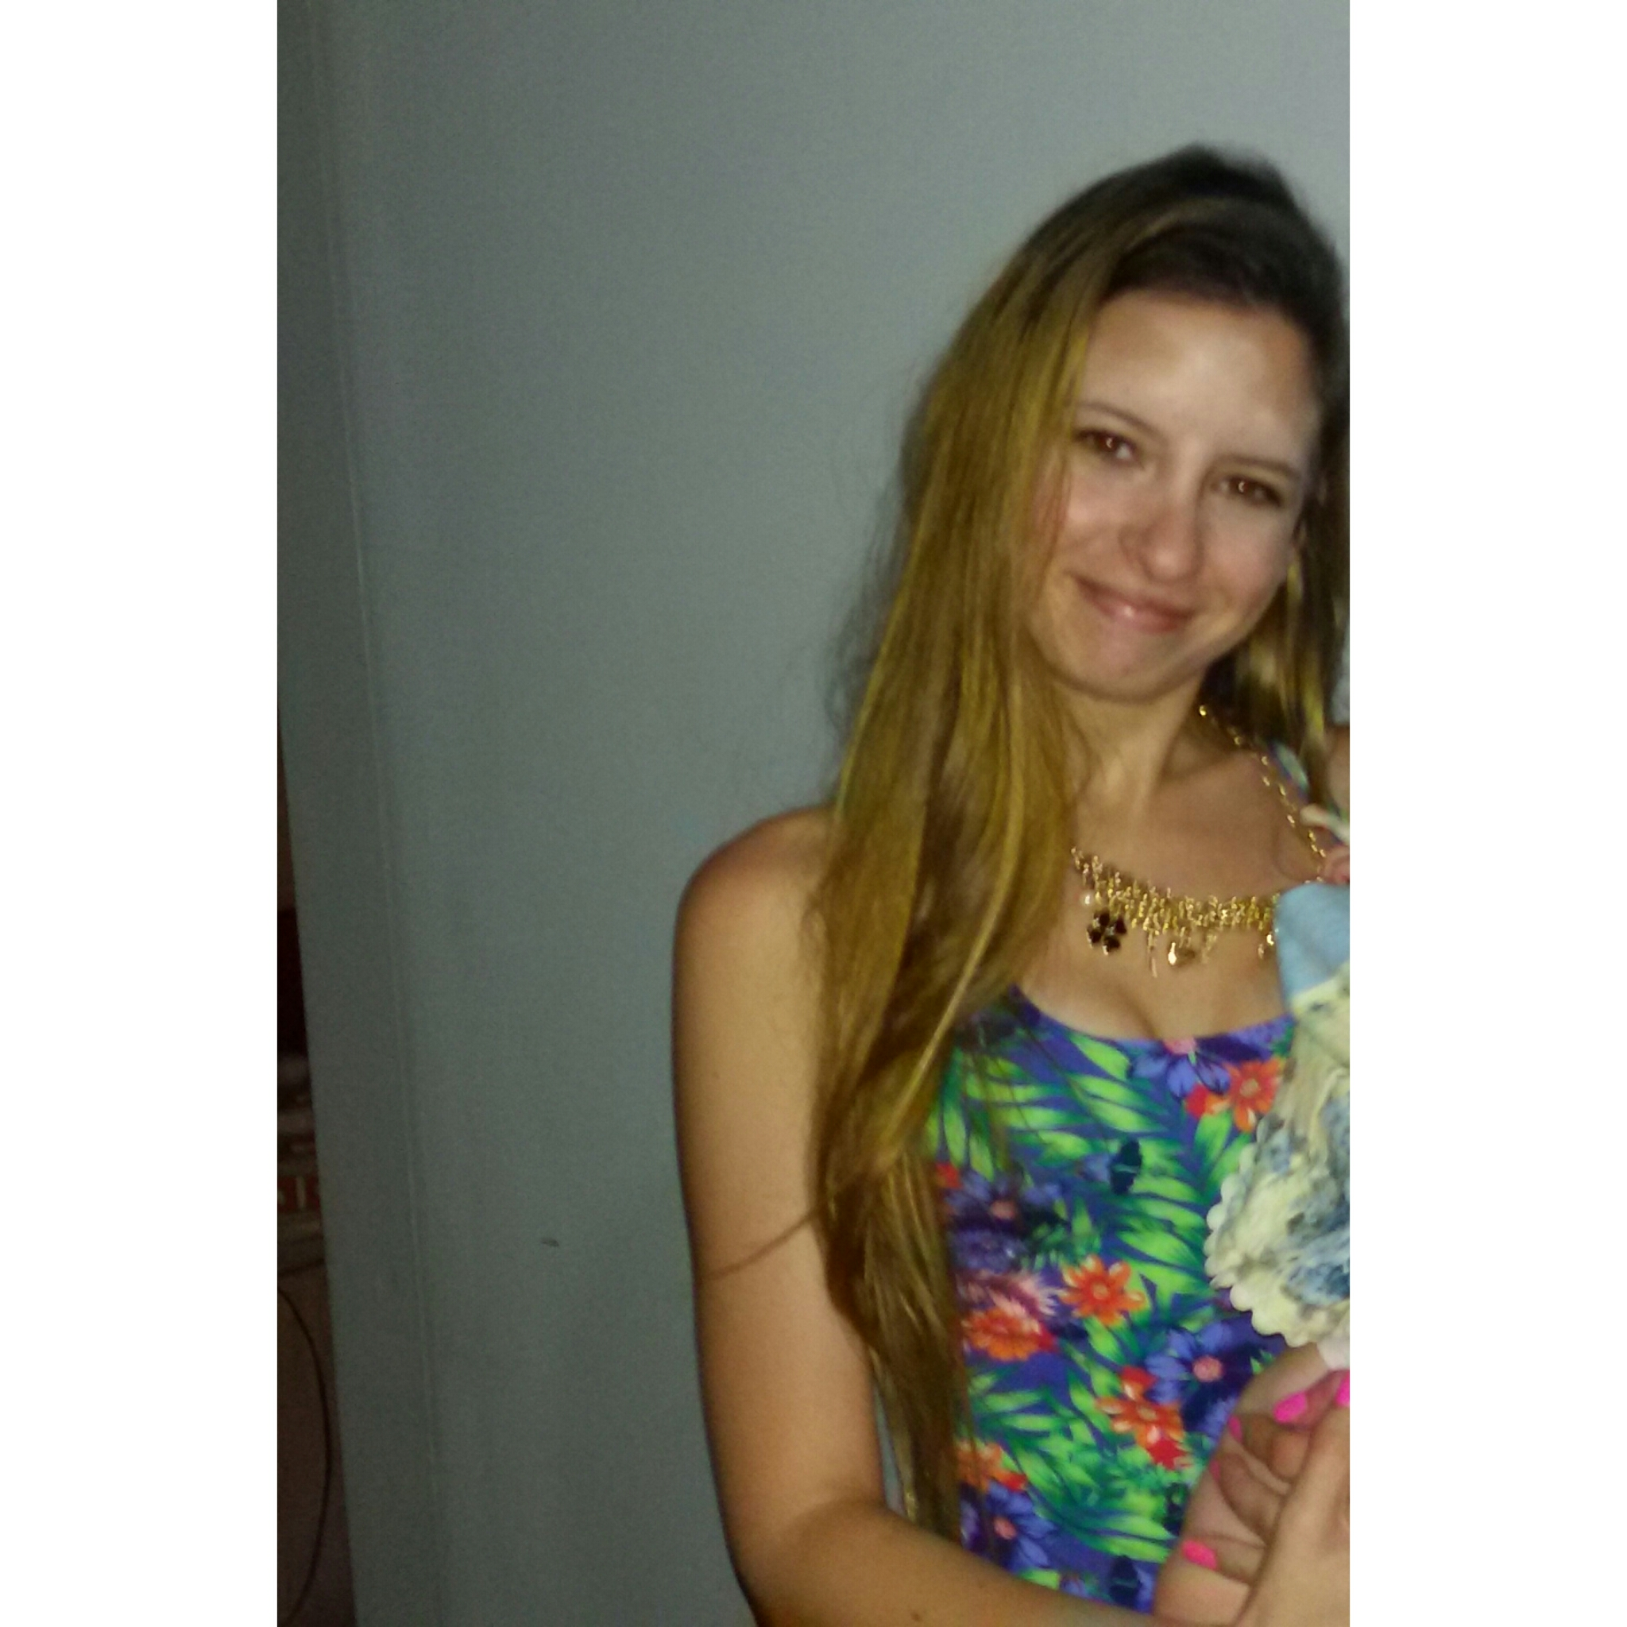 Constanza Marianela Pallini
Villa Luro, Capital Federal
Date of birth: 11/04/1995
Nationality: Argentina.
Cellphone number: 15-6711.2321
e-mail: costy123@outlook.com.ar

Work experience

English teacher:
March 2015 – At present

Freelance translator
2015- At present

Strong commitment to quality assurance

Specialties: * Medicine (Clinical Trial Protocols, Informed Consents, Manual of Medical Devices, Pharmaceuticals)

* Legal (personal and corporate documents)

* Other technical subjects: tourism, sports, telecommunications, history, market research, User's Manual.

* Rating Scale for Borderline Personality Disorder

*I have done the subtitles of “100 Days My Prince” (a serie of Youtube)

* Famale factors- conception (biological facts)

*Patient reports – Lionbridge

*Tyre fitment, nitrogen inflation, tyre balancing, tyre alignment

Translation services offered:
Translation, editing, proofreading
Freelancer for:
http://www.intertranslations.gr
http://www.lionbridge.com
https://www.marstranslation.com/
https://akorbi.com/
http://www.swaninnovation.com
https://www.tvibe.com/

Education

Freelance Sworn Certified & Literary Translator (English < > Spanish)
Universidad del Museo Social Argentino, Buenos Aires, Argentina.

Harvard University: HLS2X: Contract Law: From Trust to Promise to Contract (a course of study offered by HarvardX, an online learning initiative of Harvard University)
PEKING UNIVERSITY: Chinese for Beginners (an online non-credit course authorized by Peking University and offered through Coursera)

Other languages

English (professional)
French Level 3
Chinese Level 2

