**María Araceli Herrera Jiménez**

**Address:** Plaza Benínar 10-b, 04007 (Almería, Spain)

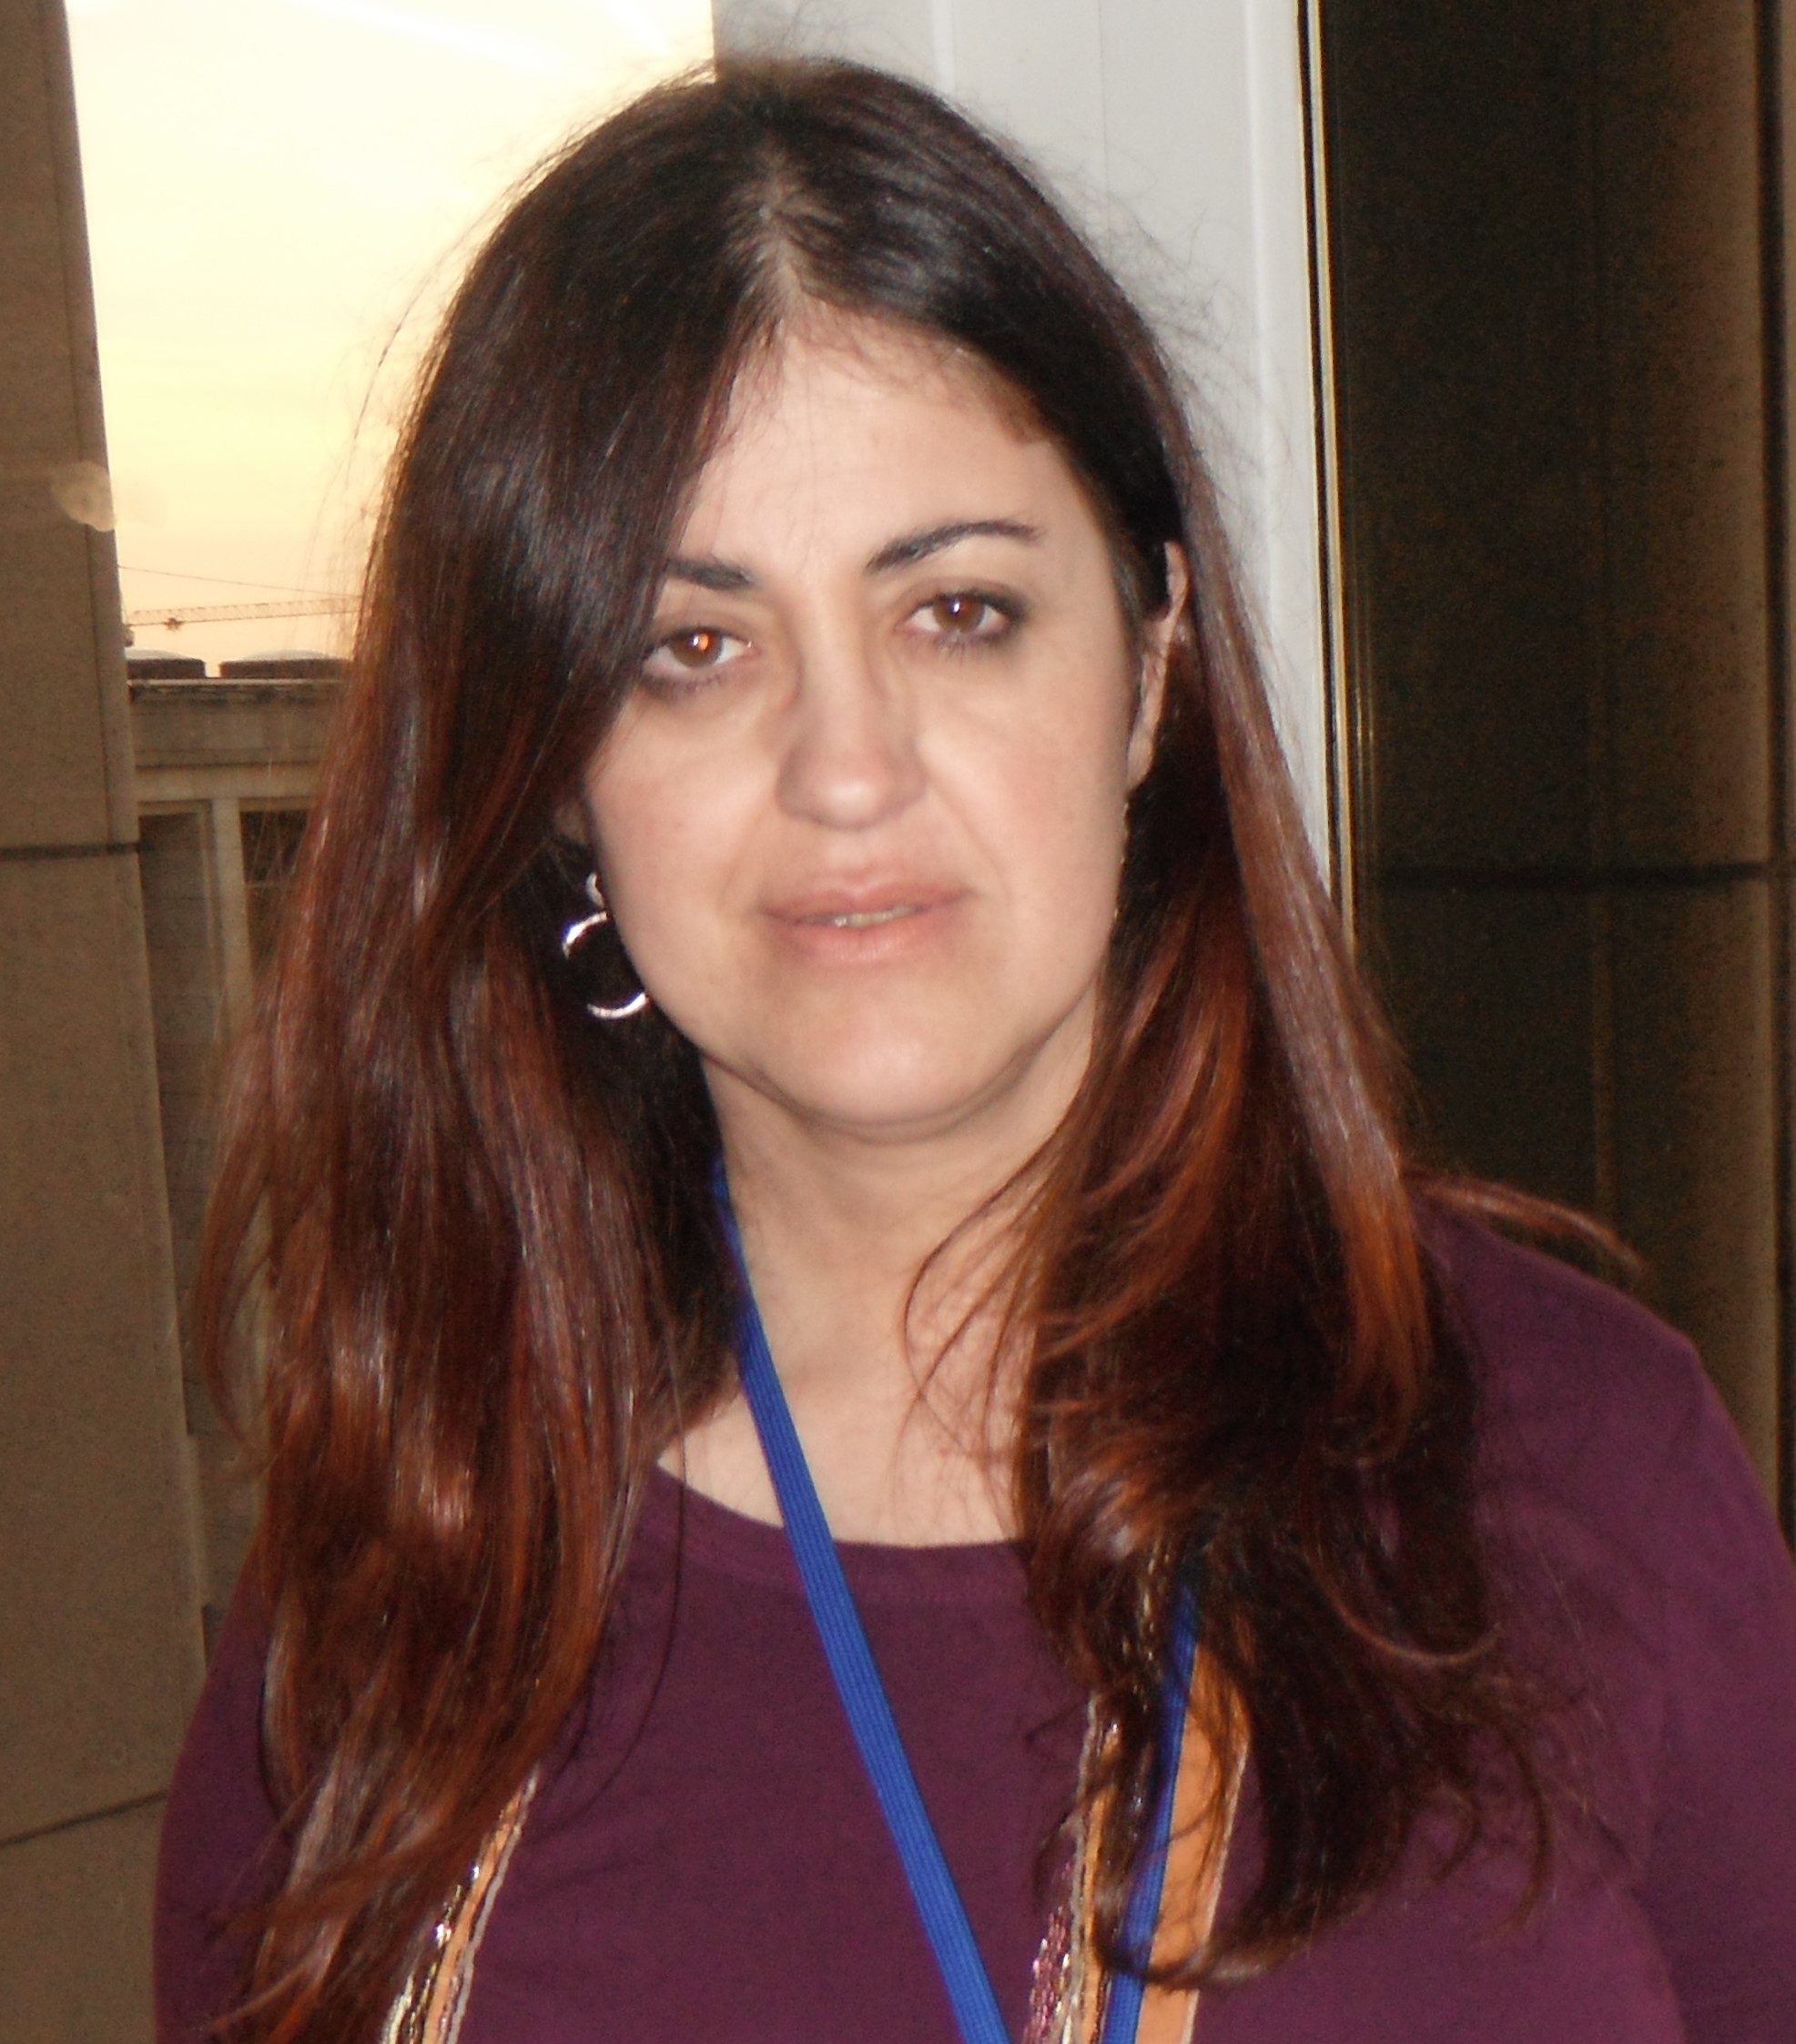

**FOTO**

**Phones:** 0034950150944-0034607154399

**Date of birth:** 03-08-1965

**E-mail:** elsaraseba@gmail.com

I am a linguist with more than 13 years of experience as a translator and proofreader, and I am lately also working as a copywriter.

I have been working for the European Parliament in Luxembourg as a trainee in the Spanish Translation Unit for five months October 2014 – February 2015. For that reason, after the five months in this place, I got much experience in all kind of subjects related to the European Parliament and the Commission from English, French and Italian into Spanish. I was chosen for this traineeship among thousands of applicants.

I’m currently studying to get the C1 in English, translating intensely from French into Spanish and I am almost bilingual in Italian. Then, I know a bit of German and can read Portuguese.

Volunteer in the Spanish Foundation of Stuttering as a translator and reviser, and in the Spanish Red Cross as a multilingual mediator (English/French/Spanish interpreter).

**ACADEMIC BACKGROUND______________________________________**

**Degree in Classical Philology** (Latin and ancient Greek). University of Granada. 1983 – 1988.

**Postgraduate Certificate in Education** (CAP). University of Granada. 1999.

**LANGUAGES____________________________________________________**

* **B2 in German**. Official School of Languages. 1999.
* **B2 in English**. Official School of Languages. 2002.
* **B2 in French**. Official School of Languages. 2004.
* **B2 in Italian**. Official School of Languages. 2006.

**FURTHER TRAINING____________________________________________**

* **Basic Course about Communication for deaf people** (Sign Language). 1998-1999.
* **Workshop about leadership for entrepreneur women** (2 parts, the second one only for 50 women chosen in the whole region, Andalusia, Spain). 2011.
* **4-month workshop about Business Administration**. Almeria. 2011 – 2012.
* **Several short workshops about personal coaching**

**COMPUTING__________________________________________________________________**

* **Workshop about Social Networks**, Cruz Roja Almería. 5 hours. 2012.
* **Workshop on Security in the Internet**, Cruz Roja Almería. 25 hours. 2011.
* **Workshop about Ofimatic** organized by Comisiones Obreras. 120 horas. 2000.
* **Workshop about Computing Applications in the Bureau**. 100 hours. 1999.

**PROFESSIONAL EXPERIENCE: __________________________________**

**TEXT TRANSLATION FROM GERMAN INTO SPANISH:**

* Some technical subjects.
* 24 tales for children and teenagers.

**TEXT TRANSLATION FROM ENGLISH:**

* Several texts about environmental worries (sciences, biography, etc.)
* Culture and Development Strategy (more than 20000 words)
* Several texts on poor countries for a non-profit organisation
* Manuals for different machines (several thousands of words)
* Several text on the VircoNet software and other pharmacy texts
* Novel “The Island” by Victoria Hislop
* Novel “Shadows in Scarlet” by Lillian Stewart Carl
* Novel “One dance in Paris” by Julia Holden
* Novel “No Regrets” by Michèle Ann Young
* Novel “Shades of Artemis” by Jon Edward Martin
* Manuals for several Haier products (About 20000 words)
* Articles and emails on stuttering for the Spanish Stuttering Foundation
* Novel “Blue Moon” by Lori Handeland
* Novel “Sweet mandarin” by Helen Tse
* Novel “The Birds and the Bees”
* Book “Redefining Stuttering” by John Harrison (almost 650 pages)
* Book, “Why We Get Fat”, by Gary Taubes (more than 500 pages)
* Documents of the European Parliament and legal in general (about 50000 words)
* The Lidcombe Program for childhood stuttering (about 30000 words)
* E-commerce for Auchan and others companies (several thousands of words)

**TEXT TRANSLATION FROM FRENCH INTO SPANISH:**

* Website about roads in the world (about 30000 words)
* Large website about Nutrition
* Cookery book, “Petites cuilleres” by José Maréchal
* Cookery book “Verrines” by José Maréchal
* Several texts for a website on a new technique to wash cars, Cosmeticar
* Several texts for the company Adidas
* Subtitles for some programs by Peugeot of Roland Garros 2008 (More than 7000 words)
* Several translations for the SNFC website (French train company)
* Website about cares for old and disabled people (more than 20000 words)
* Article about Young People and Violence (more than 43000 words)
* Several small reviews for many restaurants (many thousands of words)
* Several legal translations (contracts, general, etc.)
* Several monthly texts for the FEB (Layers in Europe)
* Texts on travel, tourism and transport : hotels, etc. (many thousands of words)
* Book « Mon secret minceur et santé » by Pierre Dukan
* Documents of the European Parliament (Minutes, Petitions, etc.)
* Little book about future (17000 words)
* Noreve website (more than 20000 words)
* Website about an Oriental religion (65000 words)
* E-commerce and distribution for Auchan and many other companies (more than 60000 words)
* Marketing translation (34000 words)
* Website on Snowboard (more than 70000 words)
* Internet (more than 30000 words)
* Mode, Luxury and Textile (almost 200000 words)
* Website on Ski clothes and tools (43000 words)
* Website on musical instruments (about 100000 words)
* Petrossian website on caviar and luxury food products (32000 words)
* E-commerce website on digital equipment (about 70000 words)

**TEXT TRANSLATION FROM ITALIAN INTO SPANISH:**

* Technical manuals
* Several recipes and texts about nutrition
* A long guide for foreign workers in Italy
* Monthly magazine about catholic religion (Padre Pio and the Pope) during more than 3 years (more than 5000 words per month)
* Several texts on tourism and travelling, especially hotels and Italian cities (about 150000 words)
* Texts for a website on illumination objects, Relco company (about 30000 words)
* Web site about lingerie (more than 14000 words)
* Article about crisis and ecology (more than 15000 words)
* Cosmetic Website (more than 20000 words)
* Manifestazione Fiera Milano (more than 15000 words)
* Documents of the European Parliament (Minutes, Petitions, etc.)
* Harmont and Blaine (20000 words)
* Website of Cermesoni Group (more than 20000 words)
* Description of products for many companies, e-commerce for Amazon, Auchan, etc. (more than 60000 words)
* Website on jewels (watches, bracelets, etc.) (40000 words)

**INTERNSHIPS:**

* Traineeship in the European Parliament in Luxembourg as a trainee in the Spanish Translation Unit. October 2014 – February 2015.
* Internship during a week in Portugal for entrepreneur women. June 2012.

**FIELDS OF EXPERTISE (with proven experience):**

Travel and tourism, cooking and food industry, literature, religion, marketing, cosmetics websites, technical (websites, manuals, etc.), EU affairs, legal (general), fashion, description of e-commerce products for Amazon, Adidas, Noreve, Chaussea, Cermesoni, Kaporal, and many other companies, etc.

**VOLUNTARY WORK____________________________________________**

* **Representative member of the Technical Committee of the Spanish Stuttering Foundation** from 2002. Translation and revision for free of a big number of articles and emails on Stuttering, and the Lidcombe Program for the early treatment of stuttering (14 years already).
* **Member of the Red Cross Almeria (Spain)** from April 2016. Specialization in Human Trafficking in slums (aid and first interview when African women just come on small plastic boats). I try to aid in the Immigrants department as a multicultural mediator as an interpreter from and into English, French and Spanish).

**Workshop in the Red Cross:**

-Specific Basic Workshop in Human Trafficking

-Basic Training in Immigrant Care in Slums

**-**Workshop inImmediate Response Teams in Emergencies of Humanitarian Aid to Immigrants (*pateras*, a large rowing boat used by immigrants to unlawfully enter Spain by sea from the North African coast).

**-**Workshop on Psychological Self-protection

**-**Workshop on Corporate Social Responsibility

**-**Workshop on Advanced Practical Training in Slums