***YELENA PESTEREVA***

***Certified English-Russian Financial and Legal Translator and Editor***

|  |  |  |
| --- | --- | --- |
| C:\Users\Елена\AppData\Local\Microsoft\Windows\Temporary Internet Files\Content.Word\20170526_154401-1.jpg | **Profile:**  **Tel.:**  **E-mail:**  **Profile page on Proz.com:**  **Location:** | **English-Russian translator and editor with 30-year experience specializing in Law and Finance. French as the second foreign language. Many years of proven experience in translating and editing. Education in the area of specialization. Strong linguistic abilities and love to work with text. Full-time freelancer since 2003.**  **+79169714893 (mob.), +74953977149 (home)**  [**pstrv@yandex.ru**](mailto:pstrv@yandex.ru)[**pestereva3@gmail.com**](mailto:pestereva3@gmail.com)  [**http://www.proz.com/pro/133492**](http://www.proz.com/pro/133492)  **Moscow, Russia** |

**KEY ACHIEVEMENTS:**

* PhD (Economics)
* Member of the Union of Translators of Russia since 2006
* ProZ.com Certified PRO freelancer since 2008
* Millions of translated words, about 30 translated books on economics, finance, psychology and law, hundreds of other translation projects completed

**FIELDS OF EXPERTISE:**

Law (Contracts), Finance, Business/Commerce, Investment/Securities, Forex, Economics, Management, Marketing/Market Research, Real Estate, Human Resources, Cosmetics, Mobile Phone Applications

**EDUCATION:**

Lomonosov Moscow State University (one of the top 5 Russian universities), economic department, Master's degree cum laude

Lomonosov Moscow State University, PhD program, PhD degree

Moscow State University of Printing Arts, post-graduate editing courses

**EXPERIENCE IN TRANSLATING AND EDITING**

Full-timefreelance translator and editor since 2003. Previously head of a bank's department, head of a unit of a research institute, lecturer of a college, in-house translator and editor of several Russian newspapers, magazines and publishing houses.

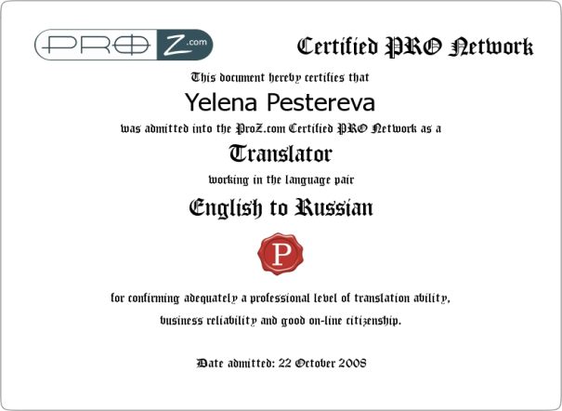

**TESTIMONIALS:**

### “Yelena has proven to be a reliable, flexible and spot-on translator to work with. She's responsive, patient and willing to help in every way. Very, very recommended!”

Greg Holbrook, Director, [Oban Multilingual](http://www.proz.com/blueboard/8695), United Kingdom

### “Yelena offers an excellent translation quality into Russian, as well as a quick turnaround. We definitely recommend her efficient services.”

Roy Solanas Jesus, Managing Director, [Excelcis SARL Translation & Communication](http://www.proz.com/blueboard/29395), Switzerland

### “Mrs. Pestereva is a very responsible person and a highly professional translator”

Nadezhda Tatyanchenko, Project Manager, Legal Translations, Russia

*“Ms. Pestereva always demonstrates the highest professional standards in carrying out the job. The accuracy of her translations and the ability to work under deadline pressure deserve a special mentioning.”*

Renata Dmitriyeva, Project Manager, S&A Translation Agency, Russia

Translation and editing of all kinds of contracts (including facility agreements and share purchase agreements), court materials, financial statements, memoranda, articles of association, bylaws, IPO prospects, investment offers, company brochures, presentations, Forex broker sites, case studies, codes of business conduct, risk management reports, internal policies, business correspondence, and other promotional, financial and legal materials and documents.

Translation of about **30 books** published by 5 leading Russian scientific literature publishers in 2004–2009, among them:

• DePamphilis, Donald, Mergers, Acquisitions, and Other Restructuring Activities (Moscow: Olymp-Business, 2007, 960 p.)

• Natenberg S., Options Volatility and Pricing (Moscow: Alpina Business Books, 2007, 544 p.)

• Pickford James (ed.), Mastering Investments (Moscow: Olymp-Business, 2006, 445 p.)

• Nobel P., International Financial Law and Standards (Moscow: WoltersKluwer, 2007, 1152 p.)

• Womack, James, Jones, Daniel, Lean Solutions (Moscow: Alpina Business Books, 2006, 264 p.)

Editing of a well-known English-Russian financial dictionary published by a Moscow publishing house.

Translation and editing of materials of UN agencies (UNFPA, UNEP, UNAIDS UNDP etc.) on a regular basis.

**LARGE CORPORATE CLIENTS:** Crédit Suisse, ABN AMRO, Citibank, JP Morgan, BNP Paribas (Suisse), Deutsche Bank, Barclays Capital, ING Bank N.V., The Bank of New York Mellon, Linklaters, Clifford Chance, Google, Canon, American Express, Bloomberg, Kraft Foods, YUKOS, RUSAL and many others.

**COMPUTER SOFTWARE:** MS Word, MS Excel, MS PowerPoint, Internet Explorer, FineReader, Adobe Acrobat, SDL Trados 7, SDL Studio 2011, MemoQ 2015, Memsource

**OUTPUT:** up to 4500 words per day

**MINIMAL RATE PER WORD FOR TRANSLATION:** $0.055, **RATE PER WORD FOR EDITING:** $20 per hour.