**RESUME**

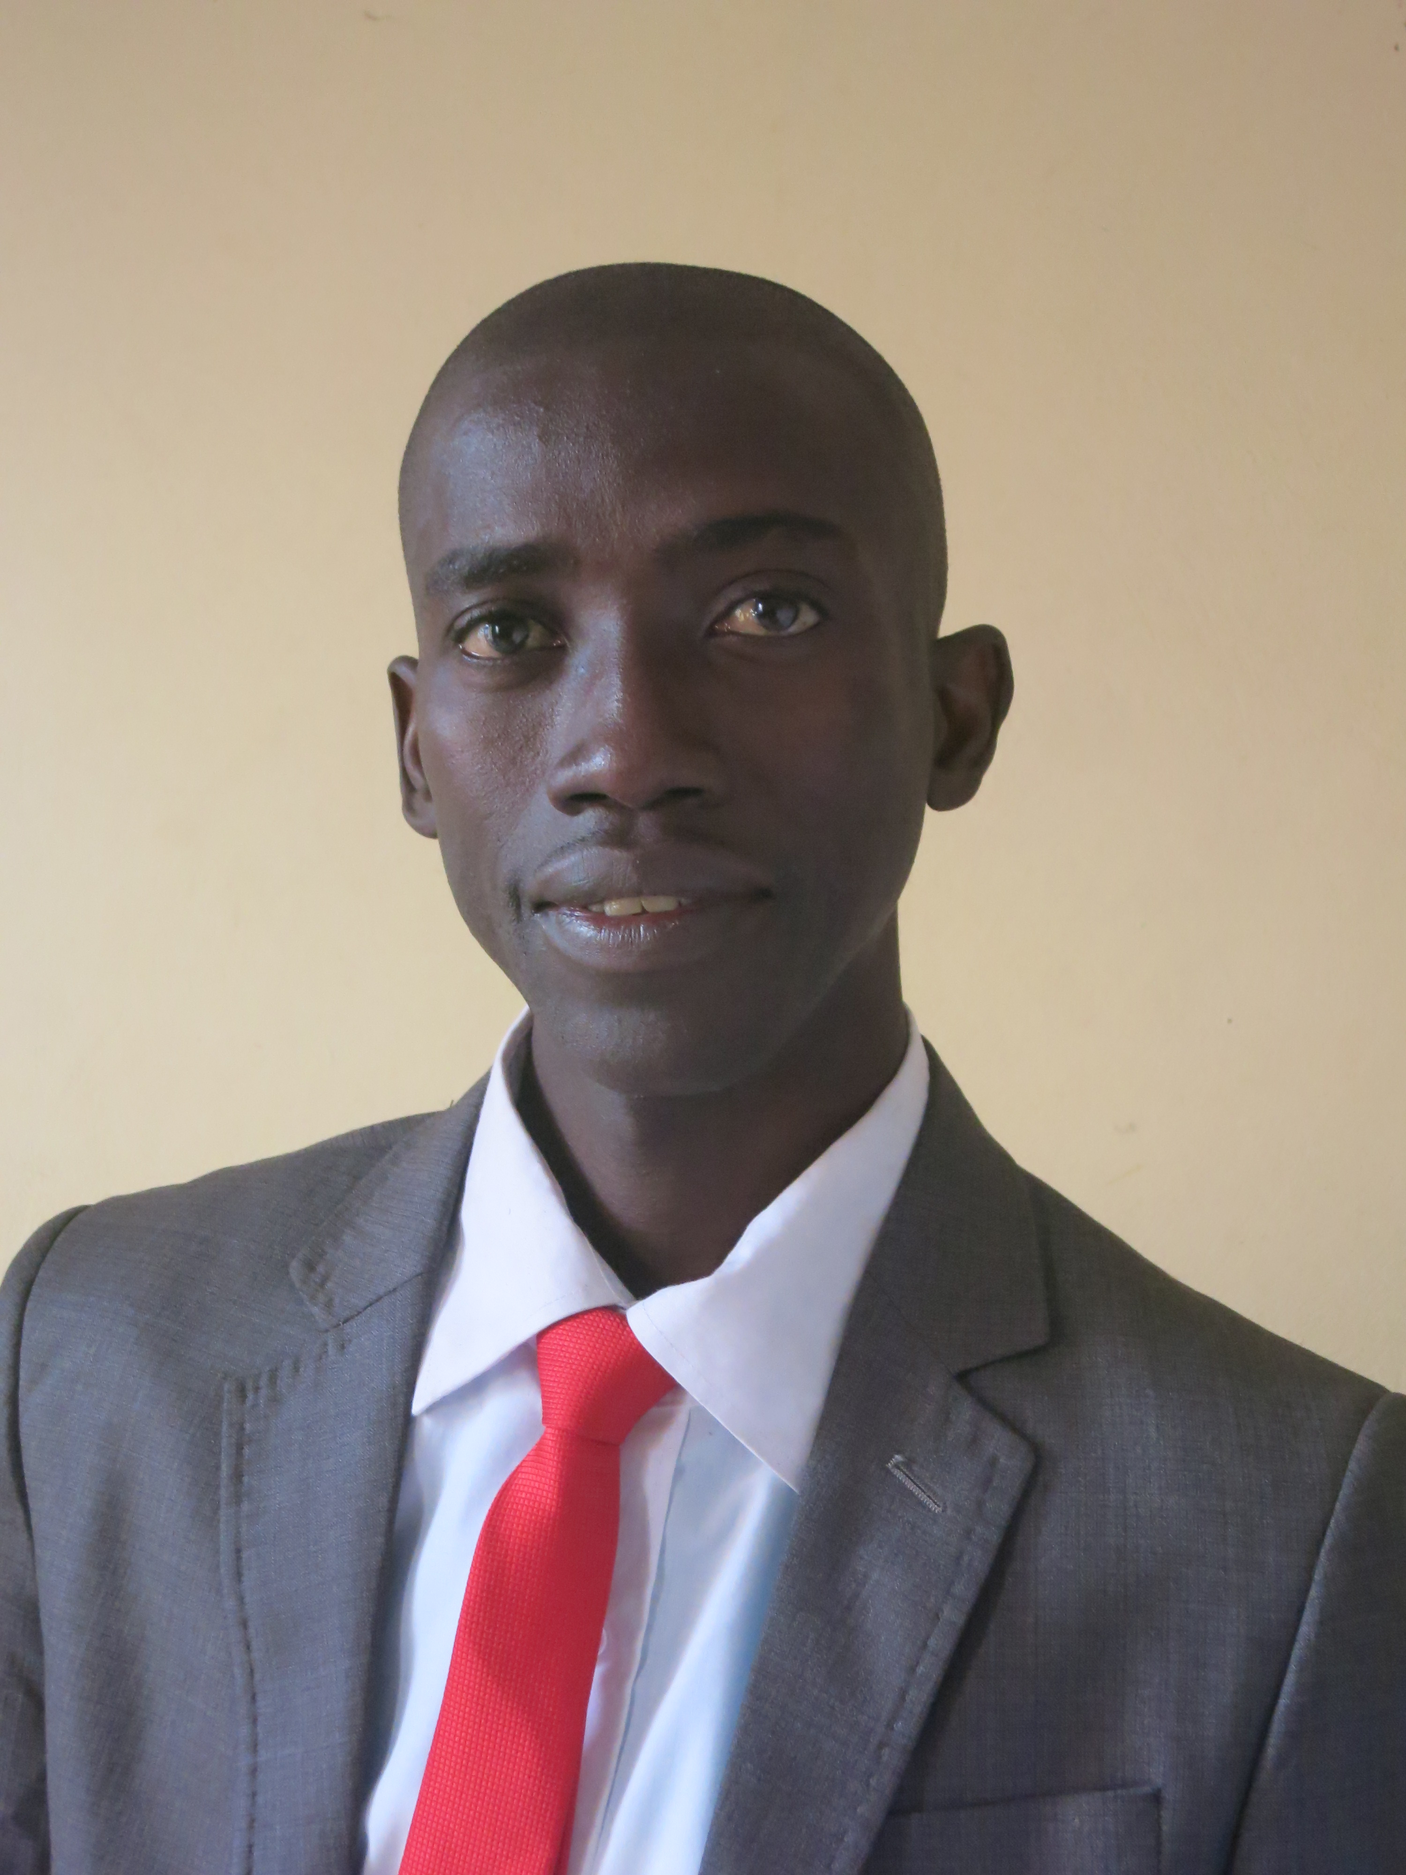

**CIVIL STATUS**

**Name: DiemeIbrahima**

**Mailing Address: Maurice Delafosse High School- IA Dakar- Senegal**

Marital status: Married – 04 children

**E-mail:** [**jemmeh33@yahooo.fr**](mailto:jemmeh33@yahooo.fr)

**Phone number: 00221 77 565 66 99 /00221 70 643 49 19**

**Date and place of birth: 03/20/1974 Bignona**

Teacher of English and Free-Lance Translator

**OCCUPATION**

***Doctorate Candidate****: 2013-2014- Anglophone and Commonwealth Studies – ARCIV (Arts and civilization)–Faculty of Arts and Social Sciences -* Cheikh Anta Diop University- Dakar, Senegal

**ACADEMIC AND PROFESSIONAL TRAINING**

***Doctorate Candidate****: 2012-2013- Anglophone and Commonwealth Studies – ARCIV (Arts and civilization)–Faculty of Arts and Social Sciences -* Cheikh Anta Diop University- Dakar, Senegal

***Doctorate Candidate****: 2011-2012- Anglophone and Commonwealth Studies – ARCIV (Arts and civilization)–Faculty of Arts and Social Sciences -* Cheikh Anta Diop University- Dakar, Senegal

***CAES****: 2011-2012- High School Teacher Training Certificate (English) - FASTEF-* Cheikh Anta Diop University- Dakar, Senegal

***ESP Certificate****:* ***25/06/2012****to****31/08/2012****-Online EFL Teacher Training- American English Institute- University of Oregon (Scholarship from the US State Department).*

**MASTER 2 English**- **2010-2011**- Cheikh Anta Diop University- Dakar, Senegal – *Upper Second class honours.*

***MA in English****-* ***2009-2010*** *-* Cheikh Anta Diop University- Dakar, Senegal – First *Class Honours*.

**CAEM-2005-2006-** Middle School Teacher Training Certificate (English) - FASTEF- Cheikh Anta Diop University- Dakar, Senegal

***B.A in English– 2001 -2002*** *Literature and civilisations- Cheikh Anta Diop University- Dakar, Senegal -*Lower Second Class Honours*.*

***CAE-CEM****-****2000-2001****- Middle School Teacher Training Certificate (French and English) -* FASTEF- Cheikh Anta Diop University- Dakar, Senegal

***BAC- 1995-1996****- AhouneSané High School of Bignona–* Pass Mark.

**2002/2004:** Teacher of French and English- Balingore Junior High School /Bignona

**PROFESSIONAL EXPERIENCE**

**2004/2005:** Teacher of French and English – Peyrissac Junior High School / Ziguinchor

**2005/2006:** In-service Teacher Training FASTEF/UCAD

**2006-2007**: Part-time lecturer- Medical English- Brighton Int’l University- Ziguinchor- Senegal

**2007-2008**: Part-time lecturer- Medical English- Brighton Int’l University- Ziguinchor- Senegal

**2006 to 2010:** Teacher of English - Peyrissac High School / Ziguinchor.

**2010/2011**: Principal by Interim Santhiaba Junior High School/ Diouloulou.

**2011-2012**: Part-time lecturer - Translation from English/French and French/English and Reading comprehension classes (Beginners) - English Department- Cheikh Anta Diop University- Dakar Senegal.

**2011-2012**: Part-time lecturer - *ILEA (Institute of Applied Foreign Languages)* Cheikh Anta Diop University- Dakar- Senegal.

**2012-2013**: Teacher of English –Maurice Delafosse High School- IA Dakar.

**2012-to present day:** Part-time lecturer - Translation - English Department- Cheikh Anta Diop University- Dakar Senegal.

**2012-2013**: Part-time lecturer - *ILEA (Institute of Applied Foreign Languages)* Cheikh Anta Diop University-Dakar-Senegal.

**2012-2013**: Part-time Teacher of English AFI-UE/ELITE- Zone B- Dakar ­– Senegal.

2013-to Present: Coordinator of Global Understanding Courses- North Carolina Agricultural and Technical University and Cheikh Anta Diop University of Dakar.

2014-2015: Part-time Lecturer of Medical English- Inter-State School of Veterinary Medicine- Cheikh Anta Diop University- Dakar –Senegal.

**ACADEMICWORK**

**2009-2010** –M.A thesis: ThePostcolonial Writer, an Analysis of the Destiny of empires in VS Naipaul’s ***The Middle Passage*** (1962) and ***An Area of Darkness***(1964).

**2010-2011**- Master II thesis: Freedom in Britain, a study of political institutions.

**2011-2012** to present day: Doctorate thesis project: La ReprésentationCulturelledans***The Buddha of Suburbia*** ( HanifKureishi), ***Brick Lane*** ( Monica Ali), ***Small Island***( Andrea Levy), ***White Teeth*** ( Zadie Smith).

**Education  
Culture**

**CENTRE OF INTEREST**

**Sport**